# : Navigating from Property Detail Page.

* Currently, when the user clicks on 🡨 (Back) Button, getting an error page. The expected behavior should be,
  + User Navigate to Property details page from the PE-Certified Properties section (on selection of the specific property)
  + We need to have on “Back” button on the property details page. If the user wishes to navigate back to the same section by clicking back button he should be navigating back to the same section (In this case PE-Certified Properties section)

(Need to check what happens when we click on 🡨 (Back) 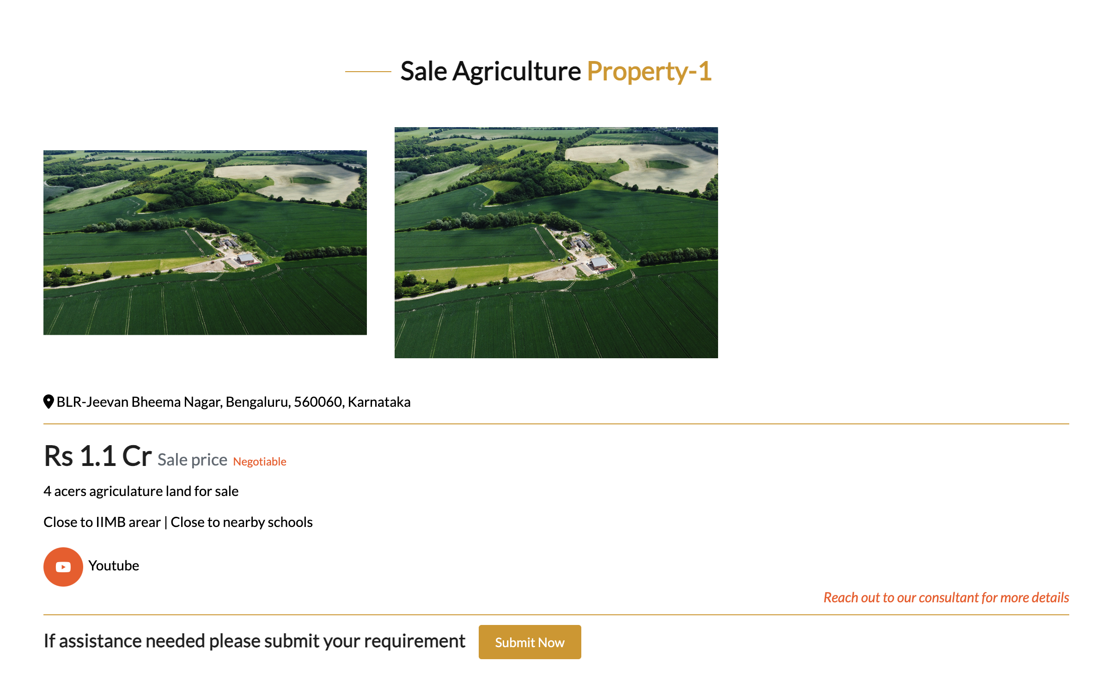

Back Bu

# : Changes in the Search pages

1. User clicks on search by typing some location
   * If matches with the search criteria pull all the related properties
   * If no match to the criteria, it should pull the list of properties [Default display]
2. Price Range – Spilt into Min and Max and use that in the query to pull the related properties (Not a must have functionality for now. But it is good to have)
3. Remove “Approximate Built-up area” field from the search page in all the property types.
4. Remove “Property Sub type” field from the search page in all the property types except for “Rent_Commercial” & “Rent_Commercials”
5. Let’s have 2 or 3 lines in the search page

1st line should be having - State | City | Location | Property Type | Price

2nd Line should display other related fields based on line 1 selection

# Picture heights and width looks differs

Hope picture size and width should be same

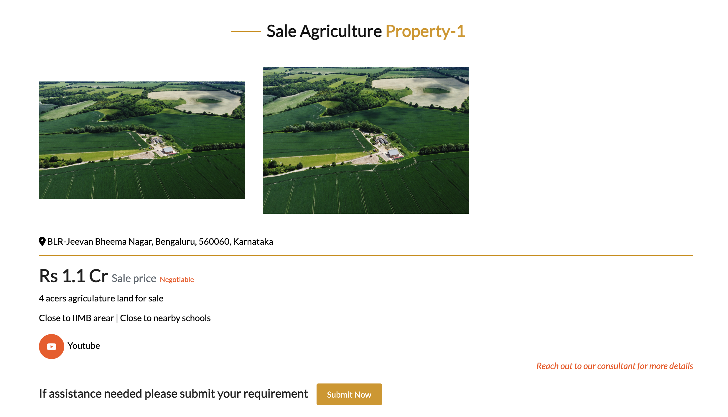

# Changes in contact page [New ask]

1. Add one more address as below

**Branch office [Bengaluru South]**

No.24 , 5th cross, 2nd Phase, J.P.Nagar, Bangalore 560078

1. Remove Google map – Just Give a “Google map” link/Button url which ever works out better for all the address
   1. Registered Office Mysore address - <https://maps.app.goo.gl/apYZwhUrpKnJM4g68?g_st=com.google.maps.preview.copy>
   2. Corporate Office

<https://www.google.com/maps?q=12.956615447998047,77.53341674804688&z=17&hl=en>

* 1. Branch Office [ Bengaluru South]

<https://www.google.com/maps?q=12.912841796875,77.58663940429688&z=17&hl=en>

Add additional address in the below section as well



# Getting error while saving property in the database.

